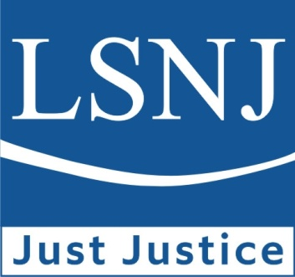

Legal Services of New Jersey
Melville “De” Miller, Jr. Justice Series
This event is proudly sponsored by Verizon, Inc.

AAPI in New Jersey
Representation, Discrimination, and Other Critical Issues Facing the Community

Wednesday May 31, 2023
Zoom Webinar

AGENDA

12:00 pm – 12:05 pm Log In and CLE Announcements (No CLE Credit)

12:05 pm – 12:15 pm Introductory Words and Panel Introductions (No CLE Credit)

12:15 pm – 1:30 pm Panel Discussion and Q&A:
Perspectives on the rise in anti-Asian discrimination and how various sectors have addressed these issues, from state agency reporting and affirmative and preventative work around bias incidents, to corporate responses, AAPI education and curriculum advocacy, and current scholarship on issues impacting the AAPI community.

PANELISTS:
- Rose Cuison-Villazor, Interim Dean, Professor of Law and Chancellor’s Social
Justice Scholar, Rutgers Law School, Newark, New Jersey
- Fannie Chan Jarvis, Community Relations Specialist and Asian American Pacific
Islander Liaison, New Jersey Division on Civil Rights
- Maria P. Vallejo, Esq., Partner, Chasan Lamparello Mallon & Cappuzzo, PC; President, Hudson County Bar; Former Director, Asian Pacific American Lawyers Association of New Jersey
- Dr. Ying Lu, E Pluribus Unum Project; Associate Professor, New York University Steinhardt School of Culture, Education, and Human Development

MODERATOR:
- Jhanice V. Domingo, Esq., Pashman Stein Walder Hayden P.C.; Legal Services of New Jersey Board of Trustees; Past President, Asian Pacific American Lawyers Association of New Jersey; Past President, National Filipino American Lawyers Association
[LSNJ, as a NJ CLE Accredited Service Provider, has presumptive approval from the Board on CLE that the above is approved for 1.5 NJ CLE general credit(s) including 1.5 diversity, inclusion, and elimination of bias and 0 ethics/professionalism credits.] [75 minutes]

1:30 pm Adjourn (No CLE Credit)

